**Flame tests Practical Assessment Total marks /30**

1. List three safety considerations and the corresponding precautions you needed to take in your flame test experiment **(3 marks)**

|  |  |
| --- | --- |
| Potential hazard | Precautions taken to manage risk |
| Bunsen burner related hazard (only one to attract mark) | Any reasonable suggestions |
| Acid-related hazard | Any reasonable suggestions |
| More detailed mention of specific chemical hazard ie. Toxic, irritant | Handling precautions/spillage management |

Must have the hazard AND an appropriate precaution to be awarded full mark

2. Display your observations in a suitable results table below. **(2 marks)**

* Headings 1 mark deducted for each of these incorrect
* ‘Substance tested’ in left column

(Mention need for ruler to draw tables – no marks deducted this time!)

|  |  |  |
| --- | --- | --- |
| Stubstance Tested | Ion | Flame Colour |
| Copper II Sulfate CuSO4 | Cu2+ | Green/Blue |
| Potassium Nitrate KNO3 | K+ | Purple |
| Sodium Chloride NaCl | Na+ | Yellow |
| Barium Nitrate Ba(No3)2 | Ba2+ | Green |
| Iron(II) sulfate FeSO4 | Fe2+ | Brown |
| Strontium Nitrate Sr(NO3)2 | Sr2+ | Red |
| Magnesium Nitrate Mg(NO3)2 | Mg2+ | Pink\sparkles |
| Lithium Nitrate LiNO3 | Li+ | Red |
| Calcium Nitrate Ca(NO3)2 | Ca2+ | Orange |

3. Use diagrams to help explain the principle behind how flame tests work. **(4 marks)**

**Remember** this doesn’t ask for a description of what you did

Maximum of 1 mark if description of method and electron diagram given only

* Electrons absorb energy and move up energy levels to excited state
* Return to ground state
* Energy is emitted (as photons)
* Photons have distinct energy matching differences in electron levels
* Energy emitted is in characteristic wavelengths, some of which are in visible spectrum
* Seen as coloured flames characteristic to each element

Example diagrams

 

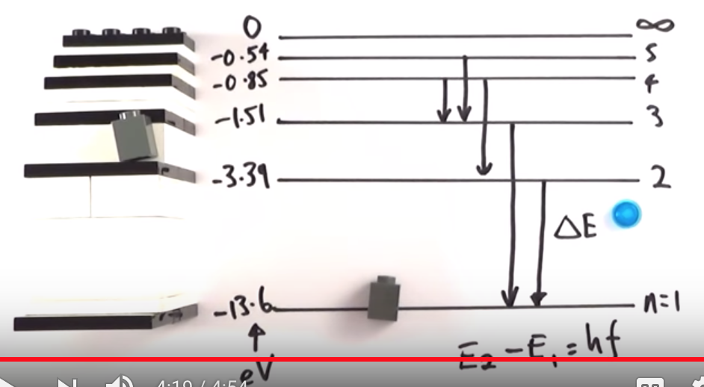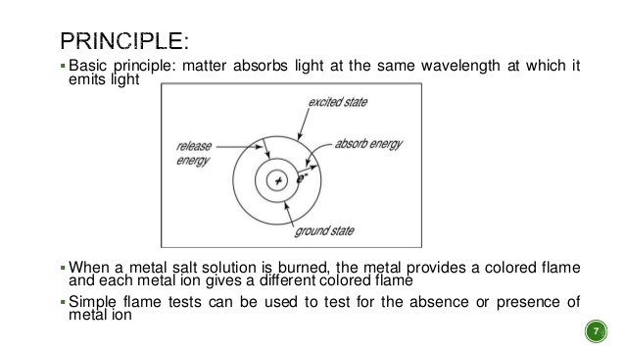

4. Explain why no two elements you tested produced exactly the same results. . **(2 marks)**

* No two elements have the same electron arrangement
* Different elements have distinct energy levels when electrons are excited
* Different nuclear structure (protons) that influence electron energy levels
* All emit different wavelengths of light
* So flame colour is different for every element

5. Flame tests can be used in a number of applications, from crime scene forensics and blood tests to the chemical analysis of food, agricultural products or medicines. Consider the following scenarios and answer the questions based on your experimental results.

a) Police are conducting tests on the contents of a salt cellar (NaCl) believed to have been deliberately contaminated in a poisoning attempt. Blood samples from the victim have revealed high levels of barium which is toxic when ingested.

i) If the salt is uncontaminated, what colour would a flame test on the contents produce?  **(1 mark)**

* Orange (or colour found for sodium in results)

ii) If a barium compound has been added to the salt, what colour might be evident in a flame test? **(1 mark)**

* Green (or barium colour from results)

b) Suggest two potential problems with using flame tests in cases like those mentioned in this question. **(2 marks)**

* Contamination produces different colours that may mask or hide the substance tested for
* Amount of sample may be insufficient to produce a spectrum
* Potential hazard with burning unknown substances
* Some colours very difficult to tell apart with naked eye

c) In routine flame tests on compounds from imported fireworks, one brand produced lilac, crimson and blue-green flames. What three cations are most likely to be present? **(3 marks)**

* Potassium K+– Lilac
* Strontium or Lithium Sr2+ or Li+ – Crimson Red
* Copper- Cu2+ - blue/green

-1 mark for including anions in answer

6. The diagrams below show two different ways of analysing the spectrum of the element Hydrogen.

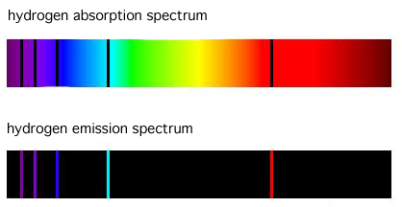

a) Which of these methods is most similar to that which you used to analyse the metal salts? **(1 mark)**

* Emission spectrum

b) By comparing and contrasting atomic absorption spectrometry and atomic emission spectrometry, explain your previous answer **(3 marks)**

* AAS – wavelengths of light absorbed when electrons are excited
* AES – wavelengths of light emitted when electrons return to ground state
* Any comparison of practical methods involved in AES and AAS
* Our method involves observing light emitted/produced
* So most similar to AES

7.   Below you will find the known spectra for five common elements followed by the spectrum recorded by a telescope for a distant star. Examine the spectra and answer the questions that follow.

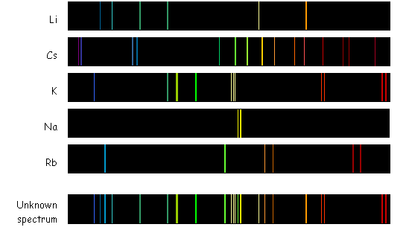

a) Potassium is an element known to be in the unknown sample. How does the spectrum of the unknown sample demonstrate this? **(2 marks)**

Distinctive bands of light shown in potassium’s spectra

Are visible/present in the unknown sample.

b) Which element is *not* in the star that produced the “unknown spectrum”? How can you tell? **(2 marks)**

* Cs (caesium)
* Spectral bands are not present in unknown spectrum

8. Some students performed a flame test on an unknown salt. A picture of the result is shown below.

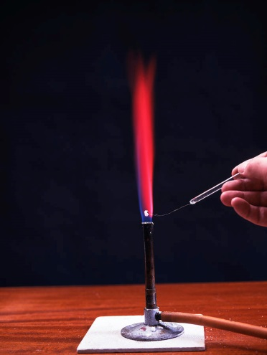

(a) From your results, predict what metal ion is present in this salt. **(1 mark)**

* Strontium (or Calcium depending on results)

No marks docked here for mentioning anion

(b) Why would you not be able to use flame tests to distinguish between sodium chloride and sodium sulfate? **(1 mark)**

* It is the metal ions that produce the characteristic colour in flame tests
* So colours would be identical

**Both** parts needed for whole mark

9. Give two practical or commercial applications of atomic absorption spectroscopy or atomic emission spectroscopy

* In forensic investigations to determine the identity and/or amount of substances present
* AAS quantitative analysis of elemental composition of substances (soil, ammunition etc)
* AES in astronomy to determine composition of celestial bodies
* AES to determine presence of metals in water or solids